Fire Risk Dashboard for Bosque Pehuén: Interactive Visualization of Wildfire Danger Using Open Meteorological Data
Felipe Guarda
Johns Hopkins University, Data Visualization Program
January 2026

Abstract
Wildfire risk assessment is critical for ecosystem and community protection in southern Chile's Araucanía region. This project develops an interactive web-based dashboard that visualizes wildfire risk in the vicinity of Bosque Pehuén, a privately protected area managed by Fundación Mar Adentro, to bolster community preparedness. The system integrates two complementary approaches: a rule-based fire-danger index using the Rodríguez-Moretti index (temperature, humidity, wind speed, days without rain) and a machine learning model trained on 20 years of regional fire history. Risk is visualized through multiple interactive representations including polar plots, dual-gauge risk displays, time-series forecasts, wind compasses with risk-coded wedges, and regional wind-flow maps. Implemented in Python using open-source libraries (Streamlit, Plotly, Pydeck), the dashboard translates complex fire science into intuitive visualizations that enable informed decision-making for fire mitigation and preparedness. The modular architecture and open-license approach ensure replicability to other protected areas.
Keywords: wildfire risk, wildfire prevention, data visualization, interactive dashboard, machine learning, open data

1. Introduction
Wildfire poses a critical threat to Chile's forest ecosystems and communities, with recent fire seasons causing extensive damage across Araucanía and Los Ríos regions (Zacharakis & Tsihrintzis, 2023). Climate change projections indicate increasing fire frequency and intensity (IPCC, 2021), making proactive risk communication essential for effective fire management.
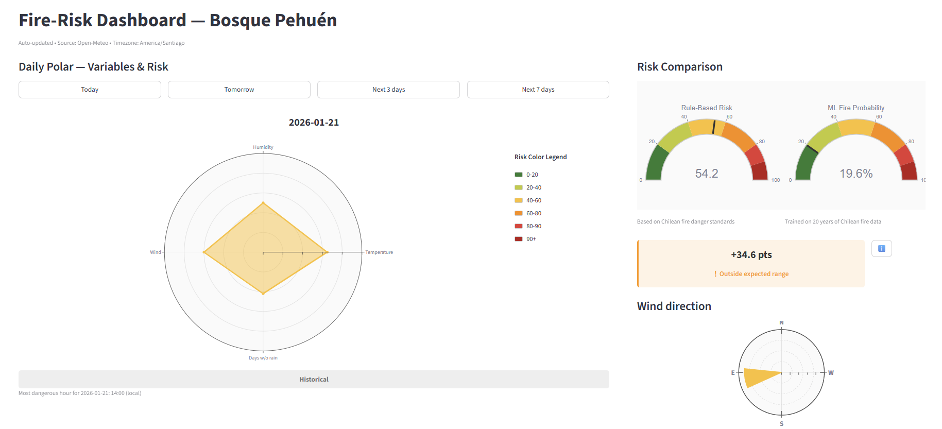
Bosque Pehuén —an 890 hectare privately protected area in southern Chile managed by Fundación Mar Adentro (FMA) —encompasses native forests including the endangered Monkey Puzzle Tree (Araucaria Araucana). While Chile's national fire-danger system (CONAF) provides regional-scale forecasts, site-level stakeholders need locally-specific, accessible risk information. This project addresses this gap by developing an open-source dashboard delivering real-time, site-specific fire-risk estimates through accessible interactive visualization.
Figure 1 Main view of the Fire-Risk Dashboard
The central research question is: How can interactive data visualization effectively translate fire science into actionable risk communication for local communities, using freely available data and open-source tools?

2. Background
Wildfire rating systems assess several key meteorological factors to predict occurrence (Zacharakis & Tsihrintzis, 2023). They are employed both at a national and regional scale. Outstanding fire risk platforms include Canada's CFFDRS, and the U.S. NFDRS. Chile's national model follows a similar architecture, incorporating temperature, humidity, wind, drought indices, and others. For ease of use and replicability using open software, here Argentina's Rodríguez-Moretti Index (IRM) was employed as a simple and effective alternative (Dentoni & Muñoz, 2012).
This project adopts a dual approach: (1) a rule-based index using the IRM with four variables (temperature, humidity, wind speed, days without rain); and for further precision, (2) a machine learning model trained on regional fire history. These methods use open meteorological data from the Open-Meteo API, and the Landscape Fire Scars Database (Miranda, A., et al., 2022).
Effective risk visualization requires clarity, multiple perspectives, and interactivity (Inglis & Vukomanovic, 2020). The dashboard employs color-coded risk scales (green to red), complementary chart types (polar plots, time-series, compasses, maps), and interactive controls enabling users to explore patterns and forecast trajectories.

3. System Design and Implementation

3.1 Data Source
The Open-Meteo API provides free global weather forecasts from ECMWF, GFS, and ICON models under CC BY 4.0 license. For Bosque Pehuén (39.61°S, 71.71°W), the system retrieves hourly temperature, humidity, wind speed/direction, and precipitation with a 14-day forecast horizon. Data are cached at startup to reduce latency.
The Landscape Fire Scars Database is an open database that maps the historical burned areas and fire severity of wildfires that occurred in Chile at a high-resolution (~30 m). The database registries span from 1984 to 2018.

3.2 Fire Risk Index and Machine Learning Model
Rule-Based Index: The system computes a composite risk score (0–100) from four variables based on the IRM. Scores are calculated for afternoon hours (14:00–16:00) when fire danger peaks, then averaged daily.
Variable | Range | Relationship | Weight
Temperature (C°) | 0–25 pts | Direct | 25%
Relative Humidity (%) | 0–25 pts | Inverse | 25%
Wind Speed (km/hr) | 0–15 pts | Direct | 15%
Days Without Rain (≥2mm) | 0–35 pts | Direct | 35%
Table 1 Fire risk index composition showing variable contributions and total score calculation
Machine Learning Model: A Random Forest classifier (100 trees) trained on 616 historical fires from Araucanía (2015-2024, Datos para Resiliencia dataset) predicts fire probability using the same four weather variables. The model achieved 80% accuracy and 0.85 ROC AUC on test data. Feature importance analysis confirmed days without rain (38%) and temperature (37%) as primary predictors, validating the rule-based weighting scheme.

3.3 System Architecture
The codebase employs a modular architecture separating concerns across six Python modules:
Module | Purpose | Key Functions
config.py | Configuration constants | Scoring bins, color mappings, geographic bounds, timezone
data_fetcher.py | API data retrieval | fetch_open_meteo() with caching
risk_calculator.py | Risk computation | compute_days_without_rain(), risk_components(), color_for_risk()
visualizations.py | Chart generation | create_polar_plot(), create_wind_compass(), create_forecast_charts()
map_utils.py | Map visualization | create_wind_flow_field(), create_map_layers()
app.py | Main application | UI orchestration, session state, dashboard layout
ml_model/fire_model.pkl | Trained ML classifier | Random Forest model loaded via joblib
Table 2 Modular architecture and key functions
This design ensures testability (independent module testing), maintainability (isolated changes), and reproducibility (version-controlled dependencies via environment.yml).

3.4 Visualization Design: Multiple Complementary Views
The dashboard integrates six visualization types to communicate fire risk from complementary perspectives:

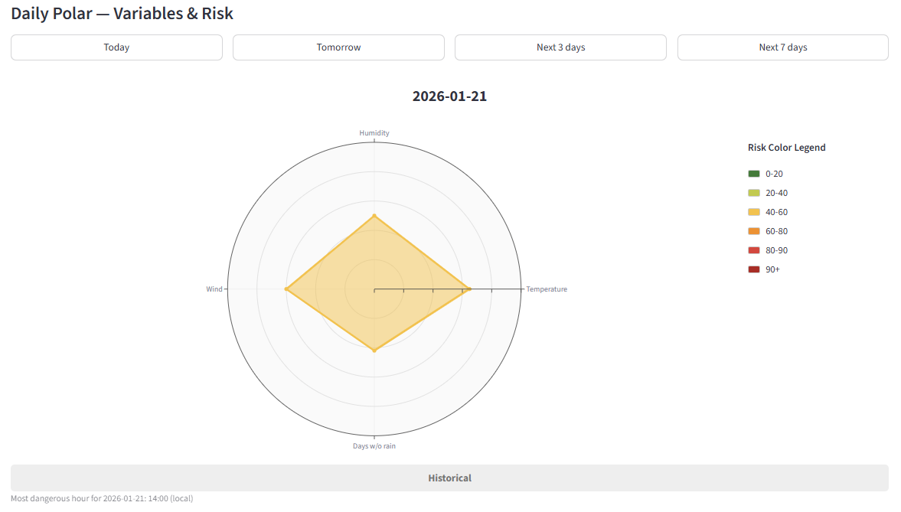
1. Daily Polar Plot: A polar coordinate plot displays the four risk variables as normalized axes (0–1 scale) rendered as a filled radial polygon. The polygon's color reflects total risk category (from green to red), instantly communicating variable contributions and overall risk level. Interactive date selection buttons ("Today," "Tomorrow," "Next 3 days," "Next 7 days") enable exploration of forecast patterns and identification of high-risk windows.
Figure 2 Polar plot visualization showing relative contributions of meteorological variables.

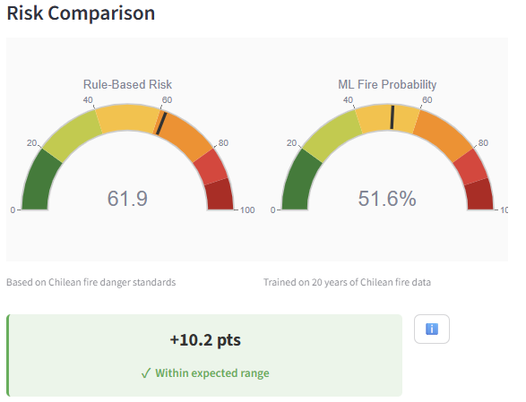
2. Dual Risk Gauge Display: Two semi-circular gauges present the rule-based risk index and ML fire probability side-by-side, enabling direct comparison. Color zones indicate risk levels, and an agreement indicator shows when methods align (within Bland-Altman statistical limits). This dual approach is made to increase user confidence by combining established protocols with data-driven predictions.
Figure 3 Risk gauge comparison for rule based and ML models

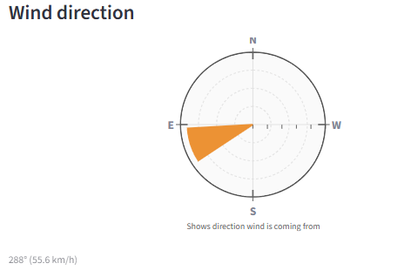
3. Wind Compass with Risk-Coded Wedge: A polar compass displays wind direction and speed using a wedge visualization. The wedge extends from the center in the direction wind is coming from, with length scaled to wind speed and color matching the day's risk level. This integration helps stakeholders simultaneously assess wind-driven spread potential and overall danger.
Figure 4 Wind compass displaying wind direction and speed

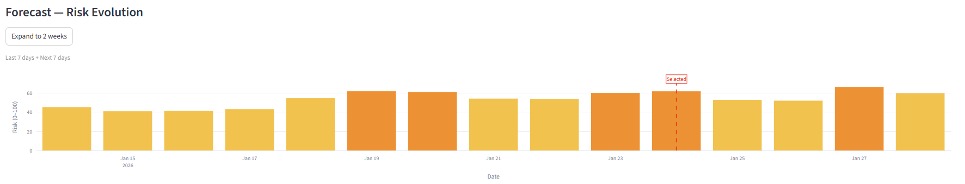
4. Risk Forecast Time-Series: A 14-day bar chart shows projected risk scores color-coded by category, which can be further extended to 21 days. It allows stakeholders a more comprehensive understanding on high-risk periods, and safe periods at a glance.
Figure 5 14-day risk forecast showing projected fire danger levels

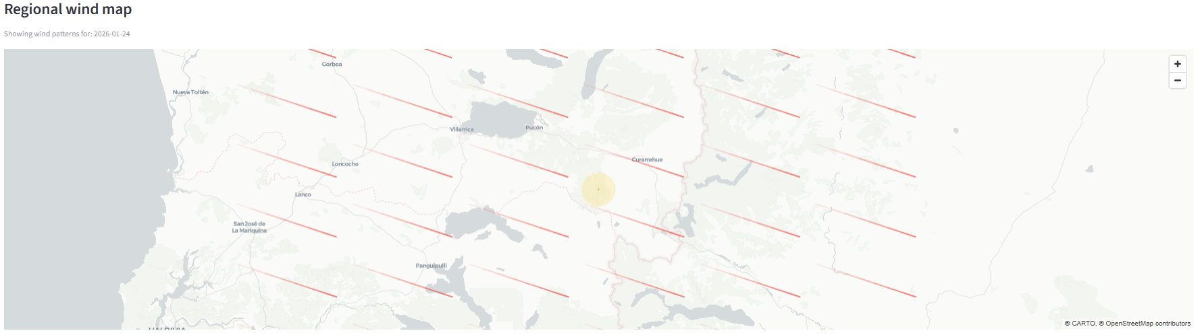
5. Regional Wind-Flow Map: A Pydeck-based map provides geographic context. Wind streamlines—directional flow lines with opacity gradients—overlay the Araucanía region, with Bosque Pehuén highlighted. This visualization communicates regional wind patterns and situates local conditions within the broader landscape.
Figure 6 Regional wind flow map displaying directional patterns across Araucanía

6. Risk Score Summary Table: A tabular display provides exact numerical scores for each variable and its total risk score, accommodating users who prefer precise numbers over visual encodings.

3.5 User Interface and Interactivity
The dashboard layout emphasizes clarity: main display with polar plot and dual gauges (left column) for immediate fire risk levels for the day, and wind compass (right column) for wind direction; the 14-day forecast, wind map, and summary table are further below, for deeper analysis. Interactive elements (date buttons, 14-day to 21-day forecast, and hover tooltips) provide basic exploration and information. The system is deployable via Streamlit Cloud or local execution using a reproducible Conda environment (environment.yml with Python 3.11).

4. Results
The dashboard achieves real-time risk assessment with 14-day forecasts, presenting fire science through accessible, interactive visualizations. Testing across seasonal conditions demonstrates accurate risk computation, and the forecast view successfully identifies multi-day high-risk periods corresponding to regional fire-danger patterns.
Model Validation: The ML classifier demonstrated 80% accuracy and 0.85 ROC AUC on held-out test data. Statistical validation comparing rule-based and ML methods using Bland-Altman analysis shows substantial agreement (concordance correlation coefficient ρc = 0.78, McNemar p > 0.05), with mean difference of 2.3 points and 95% limits of agreement within ±18 points. Both methods align on high-risk identification while offering complementary perspectives.
Reproducibility: The system is fully reproducible via environment.yml (Conda, Python 3.11) with single-command deployment. The modular architecture enables extension: e.g. new variables require updates only to risk_calculator.py and visualizations.py.
Limitations: The system uses modelled meteorological data (not in-situ sensors), potentially missing microclimate variations. Risk assessment also only focuses on meteorological hazards, not fuel load or vegetation type. The "days without rain" proxy is simpler than comprehensive fuel moisture models (e.g., Canadian Duff Moisture Code) but balances accuracy with data availability.

5. Conclusion
This project demonstrates how interactive data visualization bridges fire science and local communities, translating complex meteorological data and machine learning predictions into actionable communication. By integrating rule-based fire-danger indices with data-driven ML models, the dashboard offers both established protocols and adaptive learning from regional fire patterns.
The system's key contributions include: (1) a dual-method risk assessment combining Argentinian standars with ML trained on 20 years of regional fires; (2) a comprehensive visualization design using polar plots, dual gauges, wind compasses, forecasts, and regional maps; and (3) a modular, open-source architecture enabling adaptation to other protected areas and communities.
As climate change intensifies fire frequency across Chile, tools that democratize access to fire-danger information become essential. Effective visualization transforms raw forecasts into intuitive displays that empower communities, rangers, and emergency managers to make informed, timely decisions. Future enhancements include integration of local weather station data, automated alerting for high-risk thresholds, and regional expansion across the Araucanía and Los Ríos regions. This dashboard represents a foundation for more resilient management in Chile's fire-prone landscapes.

References
- Cavalcante, R. B. L., Souza, B. M., Ramos, S. J., Gastauer, M., Nascimento, W. R., Caldeira, C. F., & Souza-Filho, P. W. M. (2021). Assessment of fire hazard weather indices in the eastern Amazon: a case study for different land uses. Acta Amazonica, 51, 1–13. https://doi.org/10.1590/1809-4392202101172
- Datos para Resiliencia. (2024). Cicatrices de incendios forestales en Chile, 2015-2024 [Dataset]. https://doi.org/10.71578/XAZAKP
- Dentoni, M. C., & Muñoz, M. M. (2012). Sistemas de evaluación de peligro de incendios. Informe Técnico Nº 1. Plan Nacional de Manejo del Fuego – Programa Nacional de Peligro de Incendios y Alerta Temprana. Esquel, Chubut, Argentina. ISSN 2313-9420.
- Inglis, N. C., & Vukomanovic, J. (2020). Visualizing when, where, and how fires happen in U.S. parks and protected areas. ISPRS International Journal of Geo-Information, 9(5), 333. https://doi.org/10.3390/ijgi9050333
- Intergovernmental Panel on Climate Change (IPCC). (2021). Climate change 2021: The physical science basis. Contribution of Working Group I to the Sixth Assessment Report. Cambridge University Press.
- Open-Meteo. (2022–2025). Weather Forecast API. Retrieved from https://open-meteo.com/en/docs
- United States Department of Agriculture Forest Service. (2020–2025). Wildfire Risk to Communities. Retrieved from https://wildfirerisk.org
- Zacharakis, I., & Tsihrintzis, V. A. (2023). Environmental forest fire danger rating systems and indices around the globe: A review. Land, 12(1), 194. https://doi.org/10.3390/land12010194

Appendix: Fire Risk Index Scoring Summary
Variable | Range (risk score value)
Temperature (°C) | < 0 (2.7) | 0-5 (5.4) | 6-10 (8.1) | 11-15 (10.8) | 16-20 (13.5) | 21-25 (16.2) | 26-30 (18.9) | 31-35 (21.6) | 35 < (25)
Humidity (%) inverse | 91-100 (2.5) | 81-90 (5) | 71-80 (7.5) | 61-70 (10) | 51-60 (12.5) | 41-50 (15) | 31-40 (17.5) | 21-30 (20) | 11-20 (22.5) | 0-10 (25)
Wind Speed (km/h) | <3 (1.5) | 3.0-5.9 (3) | 6.0-8.9 (4.5) | 9.0-11.9 (6) | 12.0-14.9 (7.5) | 15.0-17.9 (9) | 18.0-20.9 (10.5) | 21.0-23.9 (12) | 24.0-26.9 (13.5) | >26.9 (15)
Days Without Rain | 0-1 (3.5) | 2-4  (7) | 5-7 (10.5) | 8-10 (14) | 11-13 (17.5) | 14-16 (21) | 17-19 (24.5 | 20-22 (28) | 23-25 (31.5) | ≥26 (35)
Risk computation: Scores calculated for afternoon hours (14:00-16:00) when fire danger peaks, averaged daily. Total index = sum of four variable scores.

For more information, visit : https://cwfis.cfs.nrcan.gc.ca/background/summary/fdr
For more information, visit: https://research.fs.usda.gov/firelab/projects/firedangerrating#the-nfdrs-model
For more information, visit: https://www.conaf.cl/incendios/situacion-actual-y-pronostico-de-incendios/

